I Designed a Workforce Agent That Learns from Previous Jobs
Most booking systems treat every new job as a blank slate. As the team lead of CodeNexus, I wanted to explore what would happen if our workforce coordination system could carry operational experience from one job into the next.
Our team built DayStart India, a workforce coordination platform focused on agriculture and construction. The idea is simple: customers should be able to schedule a crew, while coordinators can prepare the job using both current workforce information and relevant experience from previous jobs.
The interesting engineering problem was not simply storing previous bookings. It was making that historical information useful at the right point in the workflow.
For this, we used Hindsight as the persistent memory layer.
Designing the system around memory
As the team lead, I focused heavily on the architecture and on keeping the boundaries between the different parts of the system clear.
I wanted Hindsight to be central to the agent workflow, but I did not want historical memory to interfere with deterministic business rules.
The resulting workflow looks like this:
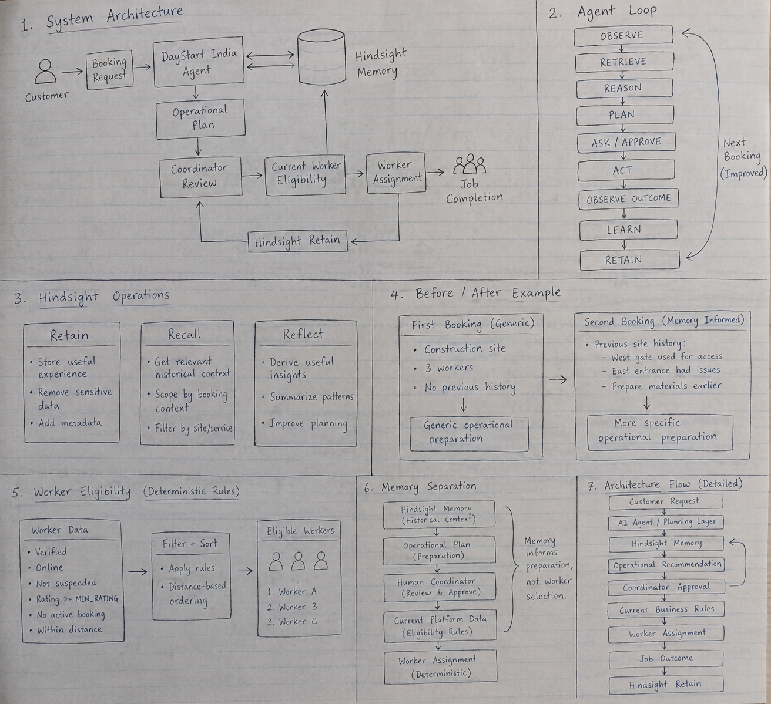
There are four important responsibilities here:
- Agent layer — understands the booking and prepares an operational plan.
- Hindsight — stores and retrieves useful experience from previous jobs.
- Business rules — determine what workers are currently eligible.
- Coordinator — reviews and approves the operational recommendation.
Keeping these responsibilities separate became one of the most important architectural decisions in the project.

Why a normal booking history was not enough
Consider a construction site where a previous crew discovered that the east entrance was difficult to use and the west gate was the practical access point.
A conventional booking system might store that information as part of the previous booking.
But storing information and actually using it are different problems.
When the next booking arrives, the coordinator still needs to find that information, understand whether it is relevant, and apply it to the new job.
I wanted the agent to be able to retrieve that operational context automatically.
That changes the workflow from:
The second approach is what makes persistent memory useful.
Using Hindsight to retain experience
We use Hindsight to retain non-sensitive operational information from completed jobs.
The system records information such as the service, site, booking context, outcome and timestamp.
A simplified version of the retention flow looks like this:
await hindsight.retain({
bankId: HINDSIGHT_BANK_ID,
context: outcome,
timestamp: new Date().toISOString(),
documentId: bookingId,
metadata: {
service,
site,
bookingId
}});
The important detail is that the memory is not intended to become a second workforce database.
We retain useful operational experience instead of unnecessary personal information.
For example:
West gate was used for crew access.
East entrance caused access problems.
Materials were easier to handle when prepared earlier.
These observations can become useful when another booking is created for the same site.
Recall changes the next booking
The most important part of the system is the before-and-after behavior.
Imagine the first booking at a particular construction site.
There is no useful historical experience available yet.
The agent can understand the current request, check the workforce and prepare a generic operational plan.
For example:
First booking

Construction site
3 workers
No previous site history

→ Generic operational preparation
The job is then completed.
The outcome is retained in Hindsight.
When another booking is created for the same site, the agent can recall the previous experience.
The result can become:
Second booking

Previous site history:
- West gate was used for crew access
- East entrance caused access problems
- Materials should be prepared earlier

→ More specific operational preparation
This is the behavior I wanted to see.
The system is not simply saying that it remembers something. The next interaction is different because it remembered.
That distinction became one of the main lessons from the project.
Retain, recall and reflect
Our Hindsight integration uses the three operations that are most important to the workflow:
- Retain — capture useful experience after a job.
- Recall — retrieve relevant historical context for a new booking.
- Reflect — derive useful context from accumulated memories.
The recall step is scoped around the booking context so that the agent is not simply retrieving arbitrary historical information.
The system also explicitly separates memory from worker selection.
For example, our recall logic is designed around the idea that:
Memory informs job preparation.
Memory does not select workers.
That distinction is important because a worker who was suitable for a previous job may not be suitable for the next one.
Keeping worker assignment deterministic
One of my main architectural decisions was to keep worker eligibility outside the memory system.
Current workforce data determines whether a worker can actually be assigned.
The system checks conditions such as:
const eligible = workers
.filter(worker => worker.verified)
.filter(worker => worker.online)
.filter(worker => !worker.suspended)
.filter(worker => worker.rating >= MIN_RATING)
.filter(worker => !worker.hasActiveBooking)
.filter(worker => distance(worker, site) <= MAX_DISTANCE);
The resulting workers are then ordered using deterministic distance-based logic.
This creates a clean boundary:
Hindsight cannot override verification, availability, rating, active booking status or distance requirements.
I made this separation intentionally because historical context and current eligibility are two different kinds of information.
Historical memory can help us prepare.
Current platform data determines what is possible.
Human approval is still part of the system
I also did not want the agent to silently turn a memory into an action.
The operational recommendation is presented to the coordinator, who can:
- Accept it
- Edit it
- Ignore it
For example, Hindsight may recall that the west gate was used previously.
That does not mean the west gate is definitely available today.
The coordinator can verify the current situation and make the final decision.
This makes the memory visible and reviewable instead of hiding it inside an automated decision.
Privacy had to be part of the architecture
Once we decided to persist operational experience, another question became important:

What should the system never remember?
The project includes sanitization before information is retained in Hindsight.
The implementation handles patterns such as:
- Email addresses
- Indian phone numbers
- Aadhaar-like identifiers
- PAN-like identifiers
- Credentials
- Long numeric identifiers
The Hindsight bank configuration also defines boundaries around sensitive information.
Our goal is not to create a giant historical database containing everything that happened during a job.
The goal is to preserve useful operational knowledge while minimizing unnecessary personal information.
That distinction is particularly important for a workforce platform.
The agent loop
As the architecture evolved, I found it useful to think about the system as a continuous loop:
A booking provides the current situation.
Hindsight provides relevant experience.
The agent uses both to prepare an operational plan.
A coordinator reviews it.
The job is executed.
The outcome becomes another piece of experience.
The next booking can then use what was learned.
This is a much more useful mental model for an agent with memory than simply thinking of memory as a database.
What was harder than expected
The first challenge was deciding what should actually be remembered.
It is tempting to retain everything because more data appears to mean more knowledge.
In practice, irrelevant history can make an agent less useful.
We therefore focused the memory around operational context: site-specific observations, previous outcomes and information that could affect preparation for a future job.
The second challenge was deciding where memory should stop influencing the system.
That is why worker eligibility remains deterministic.
The third challenge was demonstrating the value of memory clearly.
A screen showing that a database contains historical records is not particularly convincing.
The stronger demonstration is:
The behavior change is the evidence that the memory is actually useful.
An honest limitation
The current implementation also taught me an important lesson about the word “agent.”
Our project has an agent orchestration layer and genuine Hindsight retain, recall and reflect integration. However, parts of the current operational reasoning are implemented through deterministic JavaScript logic rather than a full external LLM reasoning layer.
I consider that an important limitation to state clearly.
As the team lead, I preferred having a predictable and testable memory workflow rather than adding an LLM simply to make the architecture look more agentic.
The architecture gives us a clear path for the next iteration:
The reasoning layer can become more capable without changing the boundaries around memory, business rules and human approval.
What I learned as the technical lead
There are three lessons I would carry into another agent project.
1. Memory should change behavior
The presence of stored memories is not the goal.
The real test is whether a future interaction becomes better informed because of those memories.
2. Memory should not control everything
Historical context is useful, but it should not automatically override current system state.
Separating Hindsight from deterministic eligibility rules made the architecture much easier to reason about.

3. Human approval can be a feature, not a failure
For operational workflows, an agent does not necessarily need to act without supervision.
Showing the recommendation, its historical context and giving a coordinator the ability to accept, edit or ignore it creates a more transparent workflow.
What Hindsight changed for DayStart India
Before adding persistent memory, a booking was largely an isolated transaction.
After adding Hindsight, a completed job can become useful context for the next one.
That gives the system a simple learning loop:
We used Hindsight on GitHub as the persistent memory layer, with the Hindsight documentation as the reference for the integration. The broader concept is also explained in Vectorize's overview of agent memory.
For me, the most useful test of an agent with memory is not whether it can answer:
“Do you remember this site?”
It is whether the next booking starts with knowledge that the previous booking created.
That is the behavior we wanted to build into DayStart India.

Project and Hindsight References
DayStart India source code:
https://github.com/Gssiva/Day-Start-India
Hindsight:
https://github.com/vectorize-io/hindsight
Hindsight Documentation:
https://hindsight.vectorize.io/
Agent Memory:
https://vectorize.io/what-is-agent-memory

CodeNexus — Siva Kumar G
Team Lead

